Tutorial 9 SQL – Basic SELECT statement

- What are the two major components of SQL and what function do they serve?

- Explain the function of each of the clauses in the basic SELECT statement.

- Refer to the HR Schema in the Appendix, Write SQL query that fulfill the requirements:

  - Display employee’s first name, last name and department ID.

  - Display the employee’s full name (first name join with last name) and department ID.
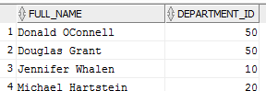

  - For employees in Department 20, list the employees in the following format:
<employee’s full name> was hired on <hire date>.
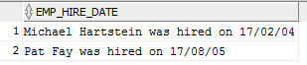

  - For employees whose phone number starts with 515, Display their first name, department ID and the following phone numbers. Name the new column as phone_num_no_area_code. Sort the result according to department id.
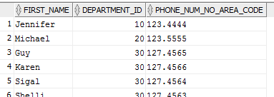

  - For employees that have commissions, calculate the annual gross salary (salary + salary * commission_pct) *12 ). List the employee’s first name, department id, and the annual gross salary according to ascending order of the department id, then by descending order of the annual salary.
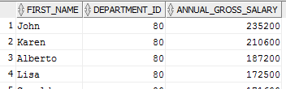

  - List the employees who join the company for more than 10 years. List the full name and the hire date. Most senior staff come first.
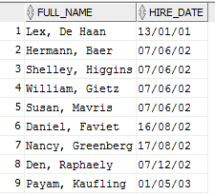

  - List without repeatition the country code in the company’s employee list.

  - List the employees’ first name, last name, and department from following countries: CA, DE, and UK.

  - List the employee’s full name and their manager’s full name for department 20. (self-inner-join)

Appendix - HR database relational schema

Schema
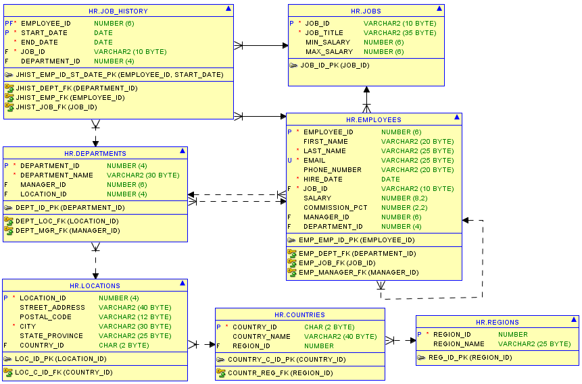

Sample Data:

COUNTRIES
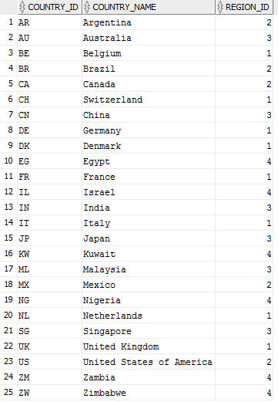

DEPARTMENTS
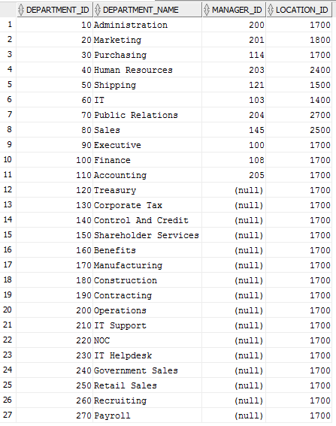

EMPLOYEES
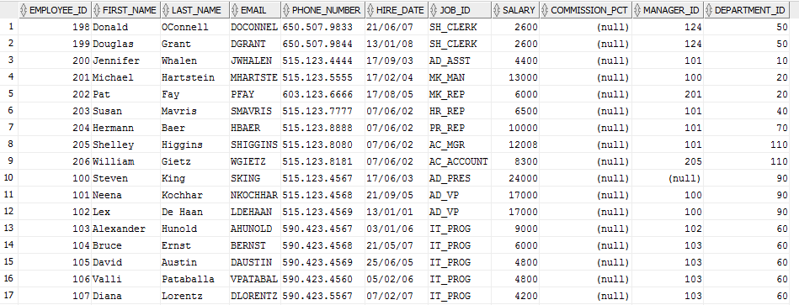
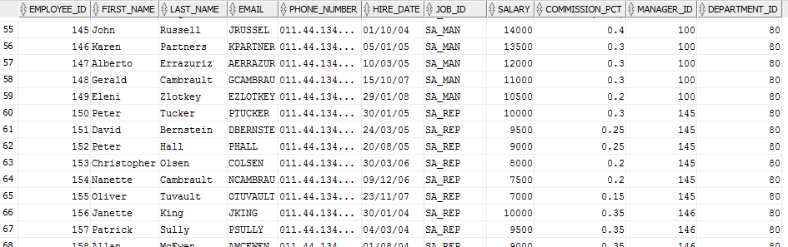

JOBS
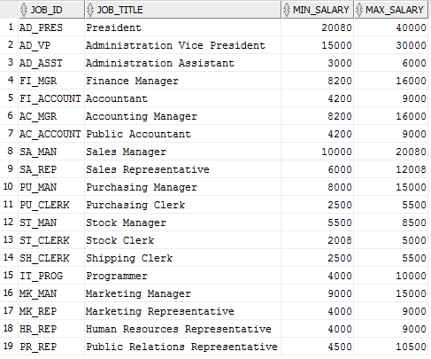

JOB_HISTORY
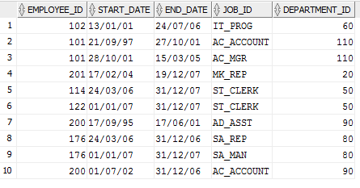

LOCATIONS
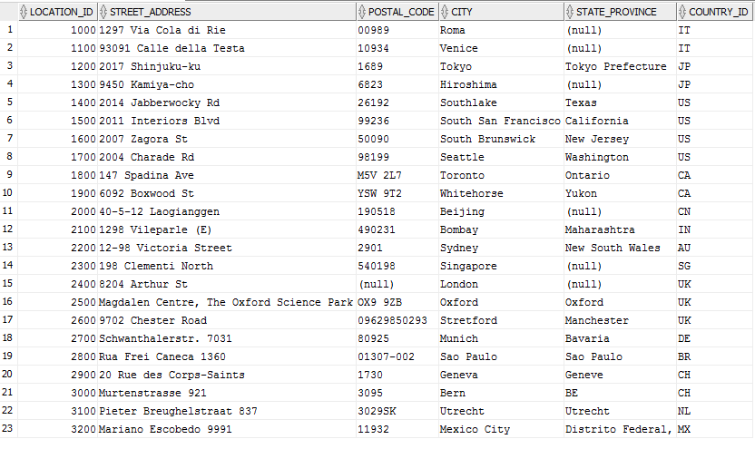

REGIONS
